**Trail Head:**

[Prepare for your Salesforce JavaScript Developer I Credential Trail mix](https://trailhead.salesforce.com/users/strailhead/trailmixes/prepare-for-your-salesforce-javascript-developer-i-credential)

[Lightning Web Components Specialist | Salesforce Trailhead](https://trailhead.salesforce.com/content/learn/superbadges/superbadge_lwc_specialist)

**HTML Fundamentals:**

[HTML Tutorial (w3schools.com)](https://www.w3schools.com/html/default.asp)

**JS Fundamentals:**

[JavaScript Tutorial (w3schools.com)](https://www.w3schools.com/js/)

**CSS Fundamentals:**

[CSS Tutorial (w3schools.com)](https://www.w3schools.com/css/default.asp)

Arrays:

[Arrays (javascript.info)](https://javascript.info/array)

[The Beginner's Guide to JavaScript Array with Examples (javascripttutorial.net)](https://www.javascripttutorial.net/javascript-array/)

**APIs used**

[Random User Generator | Home](https://randomuser.me/)

**Day 0 activity:**

**Option 1:**

1. VS Code - <https://code.visualstudio.com/download>

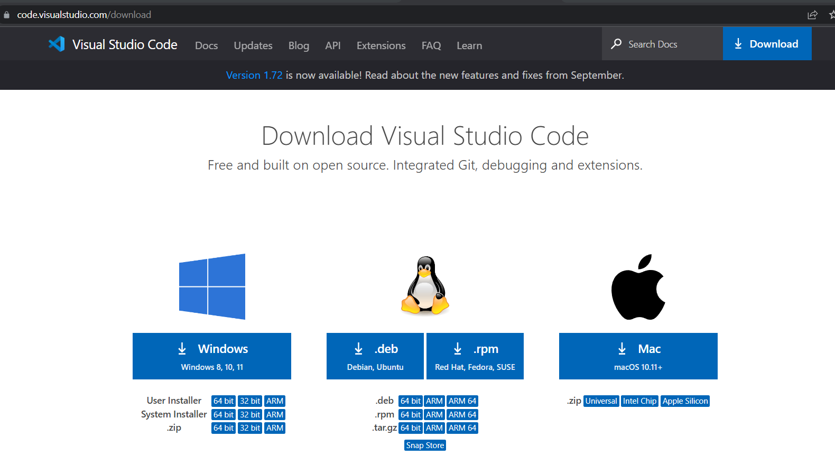

1. Salesforce CLI - <https://developer.salesforce.com/tools/sfdxcli>
2. Node.js - <https://nodejs.org/en/>

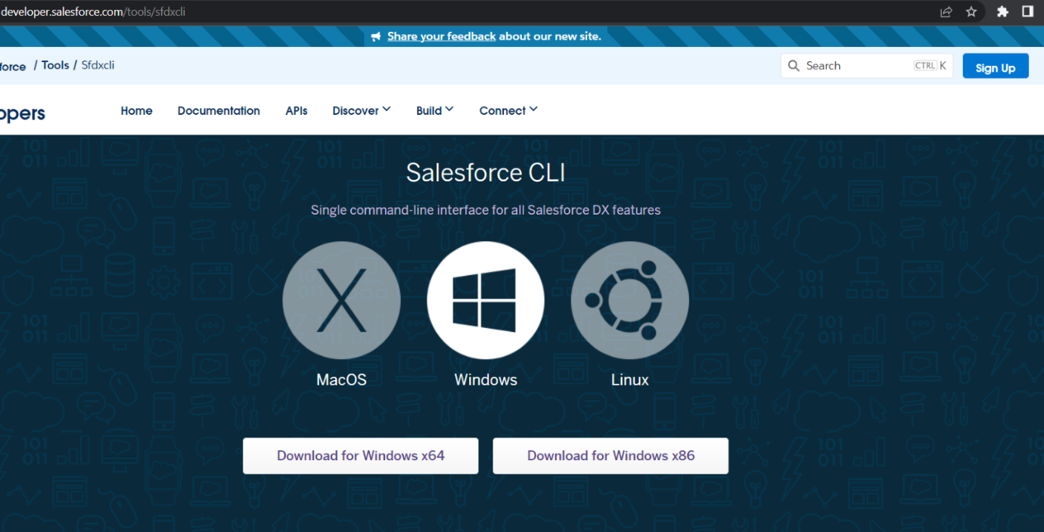

1. Salesforce Extension pack

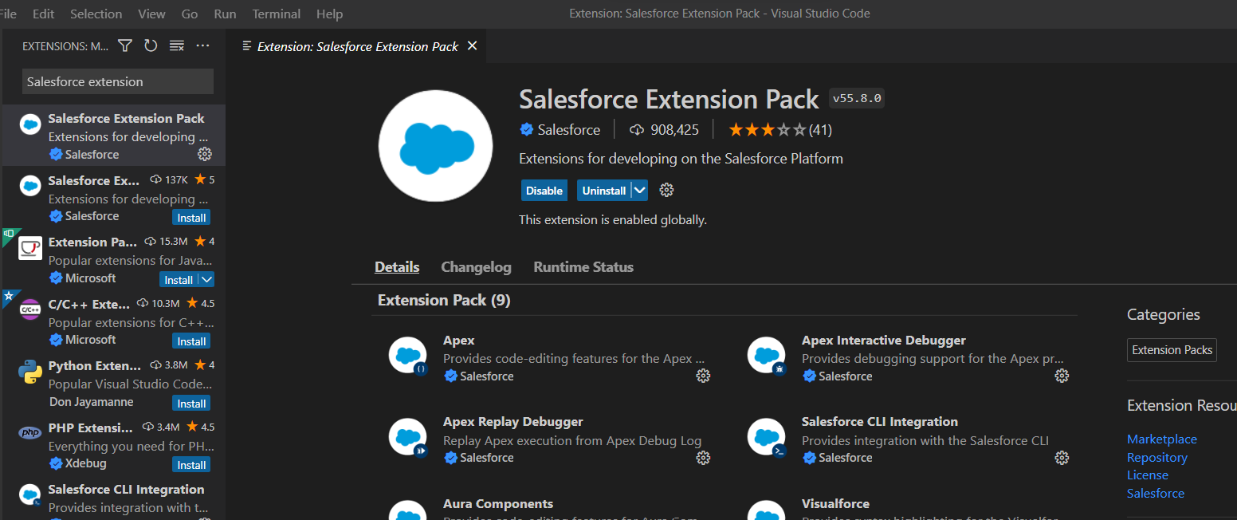

**Option 2: Code builder (beta)**

1. Org (Trailhead playground / developer Org)
2. App exchange

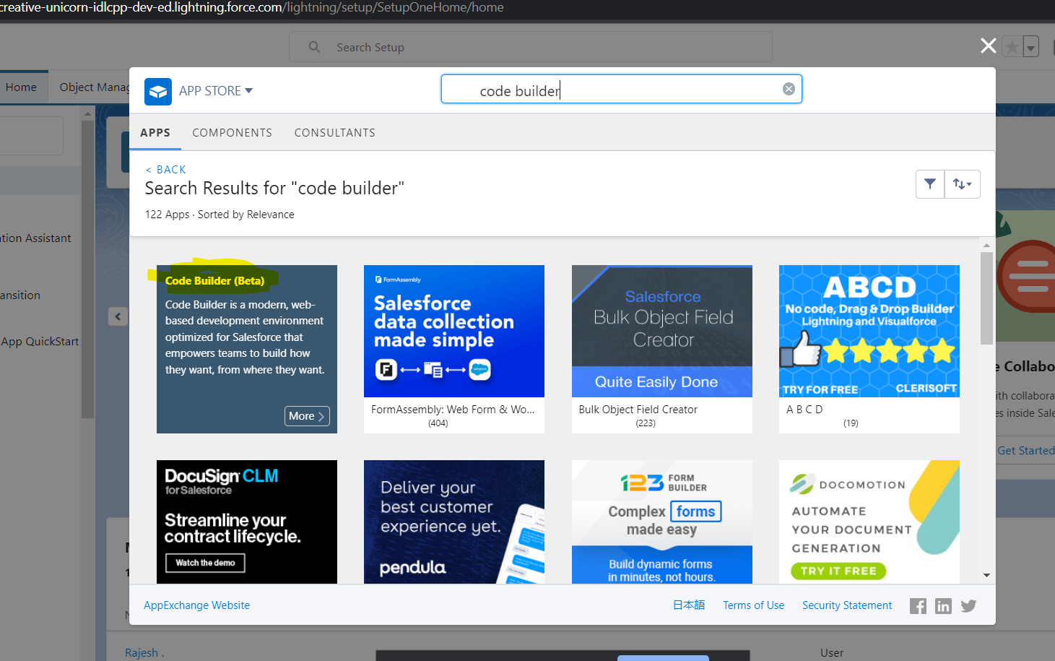

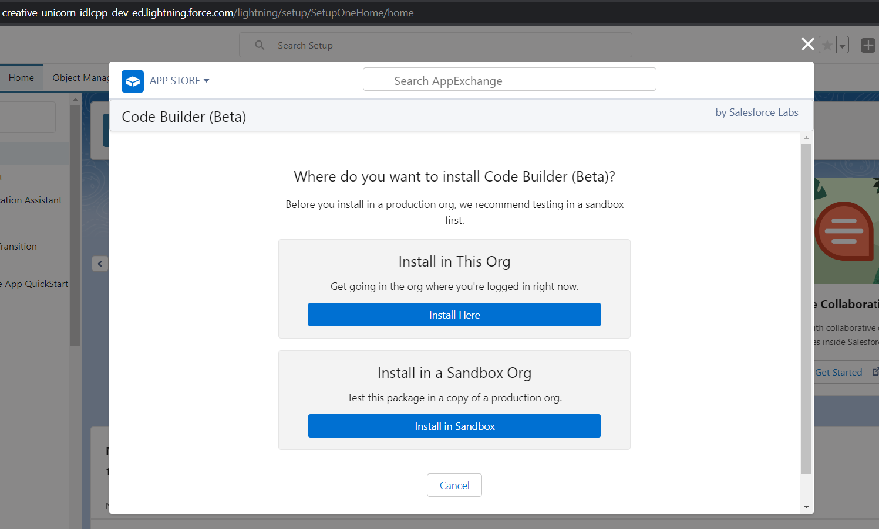

1. Launch the environment

